

Name: **Marthumallar Verajarum**

Login ID: **marthumallar@oasis-portal.com**

Course title: **Tourism and Hospitality**

Subject Code: **BHM 04**

Submission date : **11/9/2017**

**Table of Contents**

|  |  |  |
| --- | --- | --- |
| No | Details | Page |
| 1 | Executive Summary | 3 |
| 2 | Introduction | 4 |
| 3 | Assignment Question |  |
|  | Question 1 | 5-7 |
|  | Question 2 | 8-20 |
|  | Question 3 | 21-27 |
|  | Question 4 | 28-29 |
| 4 | Conclusion | 30 |
| 5 | References | 31 |
| 6 | Appendix | 32-33 |

**EXECUTIVE SUMMARY**

In this module, I had gather alots of information and I learned various ways to explain about the Tourism and Hospitality. Tourism and hospitality is a interesting topic to learn. Tourism and Hospitality is very important to everywhere. I’m going to point out more details and informations about Tourism and Hospitality and I will also explain the aspects of the question in this part. Firstly, I’m going to start the module by briefly define the Tourism and Hospitality. After that, I will elaborate about Hospitality Industry. At the same time I will explain the different types of Tourism categories. Moreover, I will describe about the lodging accommodation and types of Hotel accommodation in detail. Finally, I’m going to explain the Significant of Entertainment in this industry.

**INTRODUCTION**

Tourism is travel for recreational, leisure or business purposes. Tourism industry can be defined as a service industry. It includes transportation, accomodation and services. Tourism also activities of people traveling to and staying in places outside their usual environment for leisure, business or other purposes for not more than one consecutive year.Tourism is a dynamic and competitive industry that requires the ability to adapt constantly to customers' changing needs and desires, as the customer’s satisfaction, safety and enjoyment are particularly the focus of tourism businesses.

Hospitality is a term implies whereby a guest who is away from home is welcomed by a host where basic necessities are provided such as food, beverages and lodging. This term is derived from the latin word ‘Hospitaire’, which means ‘to receive a guest’. An industry comprises business entity of food, beverages, lodging or a combination of these businesses to travelers during their stay in a destination.



**Assignment Questions**

**Examples :-**

Assignment question in this part contain 4 questions

**Question 1**

Define the Tourism and Hospitality. Explain your understanding about Hospitality industry.

History and Development of Tourism and Hospital Industry is following below :-

Since the early 1980’s, Malaysia has steadily diversified its economy. Major changes include a departure from a reliance on the cultivation and expert of raw materials, in particular natural rubber, to a focus on services, manufacturing and tourism. Tourism in particular had a significant impact and as a generatorof foreign exchange, is second only to the oil industry. Increases in employment , development and foreign exchange earnings, however can burden a tourism infrastructure that is not fully developed.

**Development**

In tandem with the continuous growth of the tourism industry the expansion of the hotel industry has boosted the availability of hotel rooms rapidly from as low as 989 hotels in 1990 to an almost 80 percent increment at 1776 hotels in 2001. This was due to the influx of new hotels and building of additional rooms in existing hotels to fulfill the increase in tourist arrivals. Meanwhile, the room capacity in the industry increased by almost 3 fold to 130,757 rooms during the implementation of VMY 1990 campaigns.

**Tourism and Hospitality**

The industry of providing customer service to travelers or strangers. Hospitality professionals generally work in administrative or management positions in a service-based environment, and they are responsible for overseeing the operations and success of an establishment, such as a hotel or restaurant. The hospitality and tourism industry is diverse, and includes many locations including RV parks, food establishments, recreational facilities, campgrounds, boarding houses and youth hostels. While the overall goal of a hospitality professional is to ensure that guests and customers have pleasurable experiences, they can also be responsible for operations, such as hiring and training new staff; supervising office and financial administration; housekeeping, maintenance, and security staff; and marketing.

Hospitality professionals also distribute funds, set room rates, and ensure that the service standards of the business are met. General duties for hospitality professionals vary depending on the size of the business and the amount of staff available. In larger operations, there is usually a hierarchy of general managers, assistant managers, and supervisors who work to perform operational tasks relating to their areas of expertise. In a smaller business, the hospitality professional performs these tasks directly.

Sometimes hospitality professional positions are specialized. For example, some focus on managing the front office, while others can be responsible for convention services or financial administration. If a hospitality professional is employed in a specialized position, he or she must have excellent communication skills and the ability to work well alongside coworkers in other areas of the business.

Employers prefer applicants with a bachelor's degree in business or hotel or hospitality management, but a liberal arts degree along with hospitality experience may also be acceptable. Smaller establishments may accept applicants with a certificate or associate's degree in hotel, hospitality or restaurant management.

**Hospitality Industry**

Based on my understanding hospitality industry is a broad category of fields within service industry that includes lodging, event planning, theme parks, transportation, cruise line, and additional fields within the tourism industry. Usage rate, or its inverse "vacancy rate", is an important variable for the hospitality industry.

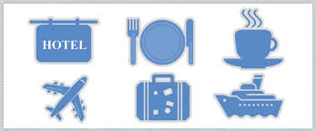

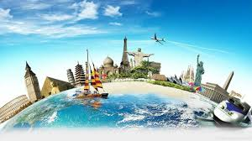

**Question 2**

Brief on different type of Tourism categories. Define Tourism.

**Tourism**

The service industries which benefit from tourism include transportation services, such as airlines, cruise ships, and taxicabs, hospitality services, such as accommodations, including hotels and resorts; and entertainment venues, such as amusement parks, casinos, shopping malls, music venues, and theaters. Tourism industry maybe defined as a group or a cluster of small firms which deals in providing attractive and affordable holiday packages to its customers either within a state, country or at international level.

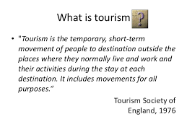

**Principle of Tourism**

Tourism means the temporary short-term movement of people to destinations outside the places where they normally live and work, as well as their activities during their stay at these destinations. All tourism should have some travel, but not all travel is tourism.

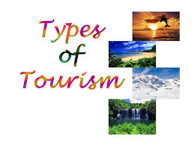

**Outbound Tourism**

Outbound tourism is what you may be most familiar with. It involves the people going from British Columbia to other provinces, territories or countries. For example, going to Hawaii for a holiday is considered outbound tourism.

**Inbound Tourism**

The tourists coming to BC from other places are called inbound tourists. BC competes in a global market to attract tourists from the United States, Japan, Germany and many other countries. The industry also implements marketing campaigns aimed at attracting travellers from other parts of Canada, as well as from within British Columbia.

**Domestic Tourism**

Approximately half of the tourists in BC each year are actually from within the province.  BC Stats and Destination BC consider those travelling beyond their usual environment (typically more than 80 km from home) for business or for pleasure to be tourists.

**Different Types of Tourism categories**

* **Leisure Tourism**

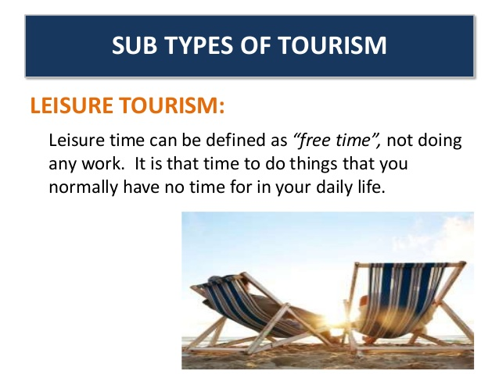

* **Cultural tourism**

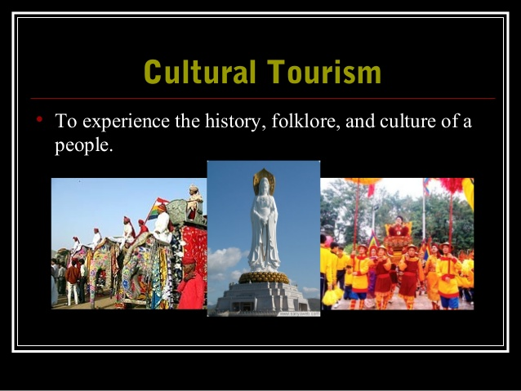

* **Religious tourism**

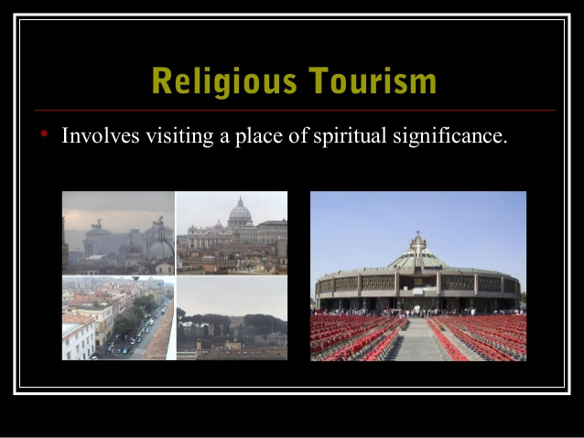

* **Family Tourism**

For children it is also imperative that **family** holidays involve social fun. **Family** holidays serve the purpose of (re)connecting people through **tourism** and can be seen as a social practice that involves networking, **family** capital formation and social obligation.



* **Health Tourism**

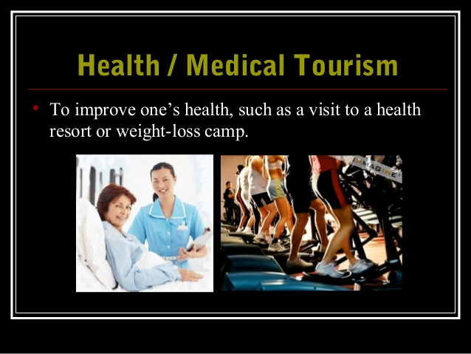

* **Sports Tourism**

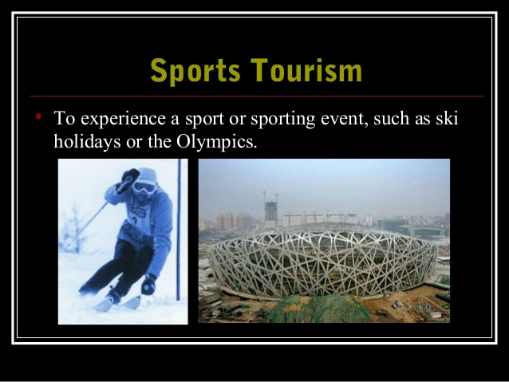

* **Educational Tourism**

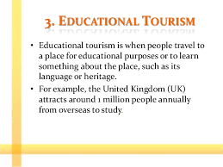

* **Business Tourism**

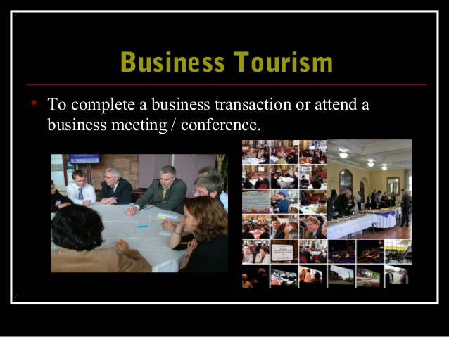

* **Alternative forms of Tourism**

Individually planned activities to gain and experience first hand knowledge about local cultures and environments. Focus on secluded areas, occur during non-peak traveling times, can include arranging own flights and accommodations

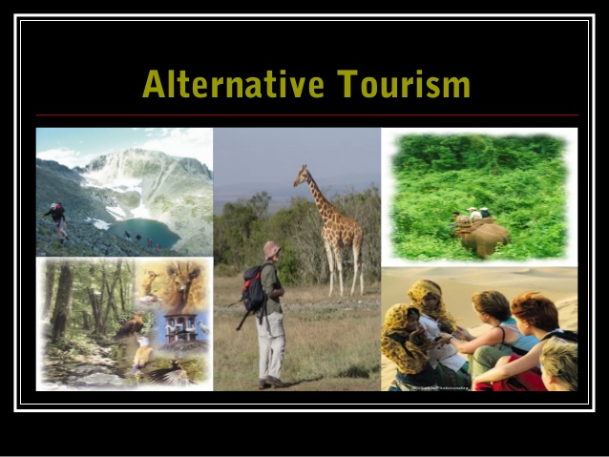

**Characteristic of Tourism**

**Perishability**

[](https://sebastiankaiser.files.wordpress.com/2012/05/hotel-room.jpg)

Perishability is one of the most important characteristics of the tourism industry. The products/services in the tourism and travel industry are consumed as they are produced. Hotel rooms and cable car seats cannot be warehoused for futures sales. When a hotel room is not booked tonight, you cannot take ‘tonight’ and sell it tomorrow. Once the train left the station, unused capacity cannot be sold afterwards – provided that it was no time-traveling train.

**Inconsistency**

[](https://sebastiankaiser.files.wordpress.com/2012/05/noise.jpg)

Products of the tourism industry always differ. Even the same hotel room in the same week with the same weather can be perceived differently due to the mood of the chef. It is always about the experience that the customer makes. Rational product attributes like price, nights of stay, and additional services can only be compared to a minor degree. It is challenging to deal with the customer perception of the product (the perceived quality) as it is highly affected by numerous uninfluenceable aspects such as weather, construction sites, other customers etc. Hence, the product is very inconsistent and cannot be standardized.

**Investment and immobility**

[](https://sebastiankaiser.files.wordpress.com/2012/05/ball-and-chain.jpg)

Talking about hotels and other accommodations there is usually a big capital lockup in the assets. Hotels have furniture, restaurants, TV-sets, laundry-service, pools, saunas etc. – invested capital that has to pay off.

And that’s not all those investments are attached to one locality which means that those tourism companies are to a huge extent dependent on the attractiveness of the region, the country, its surroundings and so forth.

**People-oriented**

[](https://sebastiankaiser.files.wordpress.com/2012/05/chef.jpg)

The tourism industry builds entirely upon people. The interaction between the staff and the customer determines the perceived product quality. Unlike tangible products where the customer buys certain features, production quality, durability etc. the holiday quality results from personal interactions starting with the information and booking process over the stay up to the journey home.

**Inseparability**

[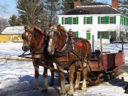](https://sebastiankaiser.files.wordpress.com/2012/05/sleigh-ride.jpg)

Most travel products are first sold and the produced and consumed at the same time. This is an aspect which clearly sets tourism apart from tangible products. When you buy a new computer it is produced and shipped before you see it on the website or at the retailer’s premise. The consumption of that computer – using it – takes place after purchase at your home. You cannot take the hotel room home – only the small bottles of shampoo and toothpaste. And you cannot enjoy the alpine sleigh ride in your living room. Tourism products can only be consumed at the supplier’s premise.

**Intangibility**

[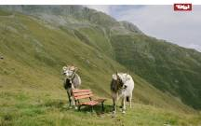](https://sebastiankaiser.files.wordpress.com/2012/05/cows.jpg)

Tourism products are intangible. A night in a hotel, a day in a ski-resort, the calm flight with the nice attendant, and the smiling tour-guide taking you to the peak of an alpine mountain – all this cannot be touched. Tourism is all about the time spent and the experience made. The products sold by tourism companies both can’t be reproduced or reused. Nor can the feeling of consumption be captured to its full extent. There are merely attempts with photographs and video cameras. Tourism is a subjective picture planted into the customers’ minds.

**Inflexibility**

[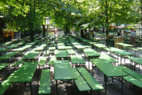](https://sebastiankaiser.files.wordpress.com/2012/05/biergarten.jpg)

Travel products are fairly inflexible in terms of fluctuation. Hotels cannot change their capacities quickly enough to react on spontaneous fluctuations in demand. Hence, such companies try to balance between high and low demands, so that it’s not too much of a pain for the company when restaurant tables remain empty and for customers when there are no more tables available.

**Imitability**

[](https://sebastiankaiser.files.wordpress.com/2012/05/photocopier.jpg)

Offers and products by tourism companies are generally easy to copy. When the neighbor hotel adds a masseur to its SPA offer you more or less only need somebody with a firm grip and here you go. So how can hotels build a unique selling proposition? Originality, consistency, location etc. – but not by hoping that their services are not imitable.

**Tourism system**

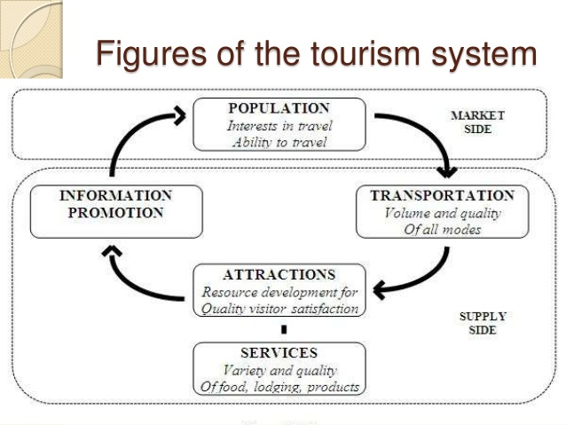

**Question 3**

Describe the lodging accommodation and types of Hotel accommodation.

**5 different sectors of the hospitality industry**

1. **Lodging-Accommodation**

This sector of the hospitality industry features a gamut from luxurious hotels to lavish resorts and campgrounds. Accommodation is an absolutely broad sector of the hospitality industry, ranging from bed & breakfast enterprises and hotels to other facilities that offer lodging services. Again, customer service is indispensable in providing accommodation services. And that isn’t all –efficiency, integrate comfort, and world-class amenities are also its foundation.

Discussed below are three main types of hotel and accommodation services:

* Lodging: When people travel from one place to the other, they need a place to sleep. A shelter which will keep them safe from the atrocities of nature. This results in people booking lodges and rooms for their stay.
* Suites: Apart from general lodges to stay, hotel sector offers luxury suites for the stay as well. Generally, suites are suitable for formal sorts of staying and are much expensive compared to regular room services.
* Resorts: The third type of accommodation which is popular among travellers are resorts. These bring you close to nature and give you a necessary break from your normal routines.

**2. Food and Beverage**

This is another crucial one among the 5 different sectors of the hospitality industry. It’s another wide sector of the hospitality industry. Food and beverage sector reign supreme in the industry. And, for good reasons. It can range from something as simple as a bistro all the way to a high-end restaurant and every catering establishment in between. As it’s expected, food and beverage industry is further sub-categorized into niches.

[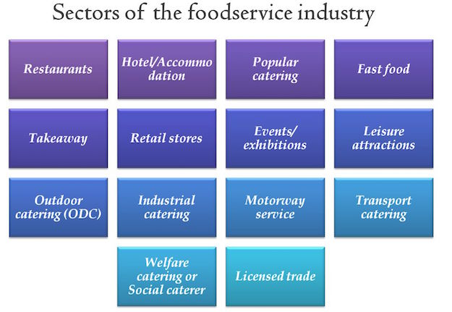](https://www.soegjobs.com/wp-content/uploads/2016/09/Food-service-industry-sectors-of-hospitality-industry.jpg)

There can be a humongous list when we categorize food service industry as a crucial sector of hospitality industry but we will list the key categories below.

* Quick-service Establishments – These are commercial foodservice restaurants that compete for customers who look to garner quick snacks, drinks, and meals. Typically, they have fewer employees. In fact, self-service is the norm here. Think of McDonald’s, KFC, Subway, Pizza Hut etc.
* Catering Businesses – This category provides food and beverage catering services for any special occasion – from weddings to birthday parties and everything in between.
* Full-Service Restaurants: These are your typical restaurants or eateries which feature course meals, drinks, and a plethora of other food services. These establishments usually seat you at a table and use waiters to take food orders. From fine-dining to casual dining to themed restaurants; there is a range of these full-service restaurants.

Themed restaurants have grown multiple folds like the wave of [luxury underwater restaurants of the world](https://www.soegjobs.com/2016/06/16/amazing-underwater-restaurants-world/). Such is the popularity and growth of Food service establishments that industry pundits are considering Full-service restaurants as a separate category of the hospitality industry.

People are always looking forward to food when they are on the go. When in a different country, people like to taste local cuisines.

So, food and catering make essentials of the hospitality industry. It starts with food production and ends at food representation on the eating tables, with storage and cooking steps resting in between.

It is also important to discuss the processes and stages involved in food service industry of hospitality.

* Food Management: It starts with the production of food. Many hotels and restaurants serve naturally organic food. Apart from production, food transportation and storage also make part of this division.
* Food Presentation: People like to eat food which is well represented. So, a lot of focus should be made on food representation to improve hospitality experience.
* Beverages: Apart from general food items, beverage storage, and representation also make it into the list of food and catering services.
* Restaurant Management: Restaurant management is a science which is being taught in colleges these days. With proper skills to manage a restaurant, you can manage food, beverages, and maintain a quality representation of food, so that customers will come again to eat at your place.

**3. Travel and Tourism**

A lot consider tourism synonymous to hospitality and not as a different sector of the hospitality industry. Travel and tourism industry is a vast sector of the hospitality industry with several key players across the globe. Most of them include trains, airlines, cruise ships, and several crew members in their service.

[](https://www.soegjobs.com/wp-content/uploads/2016/09/travel-different-categories-of-hospitality-industry.png)

On the whole, players in travel and tourism segment are in the business of moving people from one destination to another. It would not be an exaggeration if we make a statement that the most important segment of the hospitality industry is travel and tourism as others depend on it. Without profound levels of travelling and tourism in a region, hospitality industry of the region won’t grow.

So, the Travel and tourism domain makes the backbone of our hospitality industry. It is a huge domain which demands innovation, strategy, and novelty at each step.

**4. Entertainment Industry**

This again is a key category of the hospitality industry as it involves the most important thing of hospitality. Us, the buyers and recipients of all hospitality services. So, this sector of hospitality thrives for us and to entertain us. Entertainment is a significant part of our travel these days. If your travelling experience lacks fun and entertainment then you might not be able to enjoy your time up to the fullest.

So, for the successful running of a hospitality business, it is important to have in the kitty as many entertainment activities as possible.

Some of the activities which can elevate your experience when it comes to entertainment are:

* Marinas: Marinas are one of the most popular places to go when it comes to partying. You can get along with your friends on a private yacht where you can dance, play games, and enjoy the best of your life.
* Sports and Gaming: Sports and gaming is a basic thing which people are looking for on their travel. As a result, Casinos, swimming pools, and other similar activities are becoming an indispensable part of the hospitality sector.
* Cruise: Apart from marinas, cruise services are also becoming an essential component of the hospitality industry. Now, people like to spend their days on luxury ships which sail across the blue oceans under the clear sky.
* Nightclubs: Who doesn’t love to dance on their favourite song when on a break? We all do. This is why hotels have nightclubs services in them.
* Bars: Sitting around a table and having a couple of drinks with your friends is always a refreshing experience. This is why bars make an important part of the entertainment sector of the hospitality industry.

**5. Timeshare**

An emerging yet vastly important sector of the hospitality industry is vacation ownership of a place. In this scheme, people, either individuals or parties, own the rights to a place for a specific time period during the year. Timeshare gives us an option to own our choices and to enjoy facilities by either buying a part of a facility or getting into a membership plan.

**Types of Hotel Accomodation**

### Bed & Breakfast

* A Bed and Breakfast (B&B) is a private home in which guests can be accommodated at night in private bedrooms (which may or may not have private bathrooms).
* The owner or manager lives in the house or on the property. The public areas of the house, such as kitchen and lounge have either limited access for guests, or are shared with the host family to some degree.
* The business may be run as a secondary occupation.
* Breakfast is included in the price (generally either continental or full-English). Other meals may be available by arrangement.

### Backpacker Hostel

* A hostel (or backpacker) establishment is aimed at the budget traveller and generally attracts a younger clientele.
* Bedrooms are in a dormitory style (shared) and bathrooms are shared, although private bedrooms may be available.
* Light meals may be available in addition to the room rate.

### Boutique Hotel

* A boutique hotel is a 5 star establishment providing all the features and facilities of a normal hotel, in a unique and exclusive style.
* These properties are generally small, feature top class service and are marketed to the affluent.

### Guest House

* A guesthouse is generally a private home which has been converted for the dedicated and exclusive use of guest accommodation.
* The public areas of the establishment are for the exclusive use of the guests. The owner or manager either lives off-site, or in an entirely separate area within the property.
* A Guesthouse offers a wider range of services than a B&B, and usually caters for all meals.

### Hotel

* A hotel is generally the largest of all accommodation types.
* There is typically a common reception area, and rooms generally open directly onto a hallway.
* The on-site restaurant and other facilities are more accessible to the public than the other accommodation types.
* A wide range of guest services is available, such as room service.
* Hotels are often members of larger hotel groups, and a similar accommodation experience may be available in different establishments within the group.

### Lodge

* A lodge is an accommodation facility which is located and designed to optimize the feeling of being closely in touch with nature.
* The building style should feature natural materials and colouring such as wood, stone and thatch.
* An outdoor experience should be offered at the lodge, such as guided walks, game drives etc.

### Private Home

* A private home not dedicated for full time occupation of guests, but is a private house or apartment which is temporarily available for rental, often during peak tourism seasons.

### Resort

* A spread out collection of single or double story accommodation units.
* Similar to a hotel in that it offers a wide range of facilities.
* Units may be rented and available on time-share.
* A camping area may be included in the resort.

### Self-Catering

* A self catering establishment may be primarily one of the other accommodation types, but also offers dedicated self catering facilities.
* The unit should feature a fully equipped kitchen to cater for the maximum people to be accommodated including fridge, stove, cutlery, crockery, cooking utensils, cleaning equipment.
* The kitchen should be for the exclusive use of the guests, and not shared.

**Question 4**

Explain the Significant of Entertainment in this Industry.

The hospitality industry's backbone is comprised of customer service, a concept shared by all segments of the industry. Your small business may focus on one or all facets of hospitality. How accomplished you and your staff are at serving others will determine your business' level of success. You may find it easier to excel in just one category of the hospitality industry. However, though costs and challenges will increase, owning or managing several facets of hospitality can provide you with many more opportunities to generate success.

**Entertainment Industry**

Entertainment industry is a group of sub-industries devoted to entertainment. Entertainment industry is used to describe the mass media companies that control the distribution and manufacture of mass media entertainment. Generally, the entertainment industry includes the fields of theater, film, fine art, dance, opera, music, literary publishing, television, and radio. The common element found in all these fields is the fact that they engage in selling or otherwise profiting from creative works or services provided by script writers, songwriters, musicians, and other artists. It is also commonly known as show business or show biz. Live entertainment industry, music industry, film industry, electronic entertainment industry, exhibition entertainment and mass media industry are all part of entertainment industry.

**The Importance of Entertainment in Hospitality Industry**

Travel and entertainment, whether for business or pleasure, are an integral part of our culture. Accommodations, entertainment, food and beverage and travel and tourism are important components of the diverse hospitality industry.

Virtually every component of this market segment relies upon constructed infrastructure, much of which may have requirements that are unique to the hospitality industry. Converse has worked successfully across the spectrum of the hospitality and entertainment markets to meet challenges in siting, design and construction.While running a successful hotel requires a wide and diverse skillset, most professionals inside the industry wouldn't count the ability to entertain as an important part of that list. When you consider how a hotel can truly differentiate itself in the minds of the people who are actually responsible for its success.

The hospitality industry is major service sector in the world economy. The industry encompass an extensive variety of service industries that include food service, tourism and hotels. Hospitality industry suffers from fluctuations within an economy every year. Hospitality industry can be empirically divided into two parts: entertainment areas like clubs and bars, and accommodation. Accommodation takes the form of public houses, resorts, inn, campgrounds, hotels, hostels, serviced apartments, and motels. The clubs and bars category include restaurants, fast foods, and nightclubs.

The hospitality industry also includes tourism support commercial activities like airline cabin staff and travel agents. Travel technology like applied information technology (IT) and its workers in hospitality, travel and tourism are included in the hospitality industry. Corporate entertainment is also a very thriving activity amongst corporation.

A hotel is an establishment that renders lodging in lieu of payment. This lodging is usually given in exchange for a specified predetermined amount of money. Modern hotel rooms come equipped with climate control and attached bathrooms. Higher end hotels offer guests internet connectivity within rooms and also throughout the premises. A combination of meals and accommodation comes as a package in most hospitality establishments. Hotels are usually managed by professionally qualified managers. Junior workers usually maintain the hotel. Functions like cooking is usually done by professionally trained chefs.

Nightclubs are entertainment venues where dancing is accompanied by light snacks and drinking. Apart from service personnel like waiters and cooks, nightclubs employ disc jockeys (DJs) and stand up comedians as part its varied attractions. Fast-food restaurants now form a major part of the hospitality industry. These restaurants employ an optimal number of personnel for providing customer service. Food may also be sold from kiosks.[Corporate entertainment](http://www.executiveclub.manutd.com/) refers to private events held by companies for clients, stakeholders or staff. It can be in the form of conventions or conferences where a large audience is involved. Or it can be small and more private affairs like company annual parties, away days and concerts etc

**Conclusion**

Finally, I studied and focused about tourism and hospitality. Without the tourism industry there would be no hospitality industry mostly and without the hospitality industry the tourism industry would have a large gap. The large gap is because there would be no mainstream place for tourists to stay, therefore decreasing travel to that area. This causes tourism activities such as tours, excursions and tourist attractions to decline in users and therefore decreasing revenue for the local area and its people.

I say mainstream because there could still be homesteads, vacation rentals and house rentals, though depending on if you label these as businesses or not, they may be part of the hospitality industry.The hospitality industry on the other hand, is built upon the fact that as a visitor to a different destination you need a place to sleep. If people don’t travel, then people don’t need places to sleep besides their homes. There may be a hospitality industry still, but it would be tiny compared to the monstrous multi-billion-dollar industry we have today.

To summarize my answer, they need one another to function, that’s why we have tourism bureaus. These organizations help strengthen the tourism and hospitality industries in the local areas and provide additional tourism events for the local hotels and tourism business so they have business in low tourism seasons.

**References**

**1.** [**https://www.beyond.com/tourism/defined**](https://www.beyond.com/tourism/defined)

**2.** [**https://www.slideshare.net/zaiadlina_1234/chapter-1-profile-of-tourism-and-hospitality**](https://www.slideshare.net/zaiadlina_1234/chapter-1-profile-of-tourism-and-hospitality)

**3.<https://www.google.com/search?rlz=1C1CHBD_enMY752MY752&q=tourism+and+hospitality+industry+definition&sa=X&ved=0ahUKEwiF2fqD3pzWAhUJQI8KHSMiApgQ1QIIqgEoAA&biw=1366&bih=638>**

**4.** [**https://www.merriam-webster.com/dictionary/tourism**](https://www.merriam-webster.com/dictionary/tourism)

**5.** [**https://en.wikiversity.org/wiki/Tourism/Introduction**](https://en.wikiversity.org/wiki/Tourism/Introduction)

**6.<https://www.google.com/search?q=Types+of+tourism&rlz=1C1CHBD_enMY752MY752&tbm=isch&tbo=u&source=univ&sa=X&ved=0ahUKEwiH5Iju_JzWAhVBu48KHdMrBKcQsAQIMw&biw=1366&bih=589#imgrc=5IitOZtpPK7vdM>:**

**7.** [**https://www.slideshare.net/ALTINBAKU/the-different-types-of-tourism**](https://www.slideshare.net/ALTINBAKU/the-different-types-of-tourism)

**8.**[**https://www.google.com/search?q=principle+of+tourism&rlz=1C1CHBD_enMY752MY752&oq=principal+of+tourism&aqs=chrome.1.69i57j0l5.178737j0j9&sourceid=chrome&ie=UTF-8**](https://www.google.com/search?q=principle+of+tourism&rlz=1C1CHBD_enMY752MY752&oq=principal+of+tourism&aqs=chrome.1.69i57j0l5.178737j0j9&sourceid=chrome&ie=UTF-8)

**9.** [**https://sebastiankaiser.wordpress.com/2012/05/21/characteristics-of-the-tourism-industry/**](https://sebastiankaiser.wordpress.com/2012/05/21/characteristics-of-the-tourism-industry/)

**10.** [**https://www.go2hr.ca/bc-tourism-industry/what-tourism**](https://www.go2hr.ca/bc-tourism-industry/what-tourism)

**11.** [**https://www.quora.com/What-is-the-relationship-between-tourism-and-hospitality-How-close-do-they-have-to-work**](https://www.quora.com/What-is-the-relationship-between-tourism-and-hospitality-How-close-do-they-have-to-work)

**12.** [**http://www.businessdictionary.com/definition/accommodation.html**](http://www.businessdictionary.com/definition/accommodation.html)

**13.** [**https://www.allaboutcareers.com/careers/industry/hospitality-tourism**](https://www.allaboutcareers.com/careers/industry/hospitality-tourism)

**14.** [**http://www.tourismtattler.com/articles/hospitality/importance-hotel-entertainment/65161**](http://www.tourismtattler.com/articles/hospitality/importance-hotel-entertainment/65161)

**15.** [**http://www.converseconsultants.com/core-markets/hospitality-entertainment**](http://www.converseconsultants.com/core-markets/hospitality-entertainment)

**APPENDIX**



[](https://www.soegjobs.com/wp-content/uploads/2016/09/Food-service-industry-sectors-of-hospitality-industry.jpg)